**Aidan Brown**

**GEOG 501 Fall 2023**

# Deliverable 1

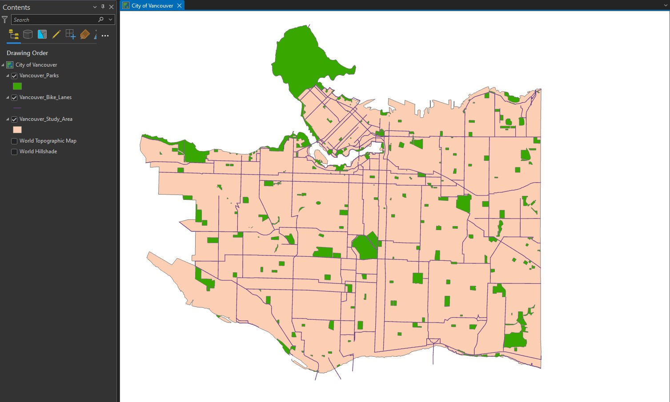

**Deliverable 2**

Total Area in Hectares for Burnaby in the nearest decimal place is 9122.0.

**Deliverable 3**

Based on the **GVRD_Bus_Routes** attribute table. The total number of bus routes is 191.

# Deliverable 4

Adding all the **Length_km** fields from the **GVRD_Bus_Routes** attribute table of all bus lines that arrive at UBC, the total is 480 KM. There are a total of 12 bus routes that go to

UBC.

# Deliverable 5

Distance between University Hill Elementary and Franklin Elementary schools is 15.00 KM.